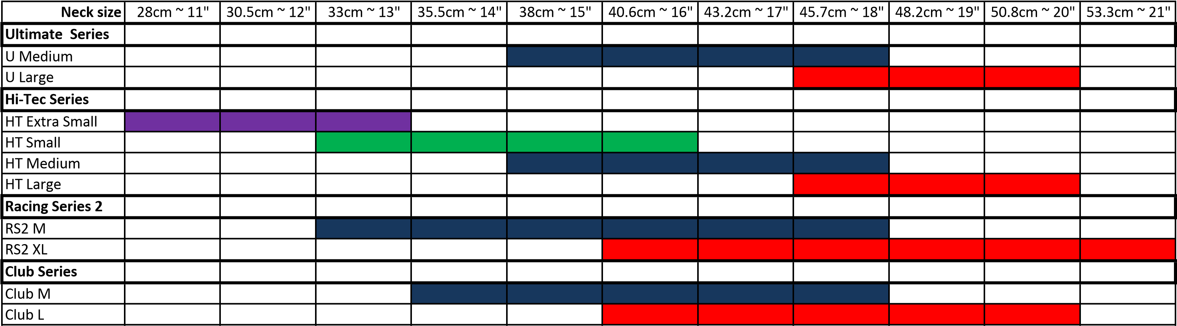

NOTE – Our Range is the Club Series – Note we can get all series, Phone Kent on 0400009024

Buy_Afterpay_Zip Pay_Humm_Pro1 Money
www.pro1raceparts.com.au

