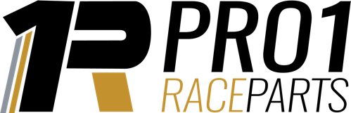

JOB TITLE: Lead Salesperson – Motor Racing Industry

JOB TYPE: Fulltime

LOCATION: 209 Pallas St, Maryborough, 4650 Queensland

MAIN DUTIES/RESPONSIBILITIES:

• Selling products, goods and services with exceptional customer service
• Trackside weekend sales
• Submitting and processing customer orders
• Overseeing dispatch staff
• Planning sales strategies and new sales avenues
• Working to key performance indicators (KPIs) and sales targets
• Attending conferences and trade shows
• Ensuring a safe, clean environmentally friendly workplace

SKILLS & EXPERIENCE
Qualifications and Skills

• Strong communication skills, both written and verbal
• Excellent customer service skills
• Relationship management skills
• In-depth knowledge of the company’s products or services
• Effective time management skills and an ability to prioritise tasks while working without supervision
• Proficiency in the use of CRM (customer resource management) programs as well as Microsoft Office suite
• A driver’s license and access to a vehicle
• Experience or the willingness to gain skills in Warehousing and/or Graphic Design

